**Harris Academy**

**Higher Music**

[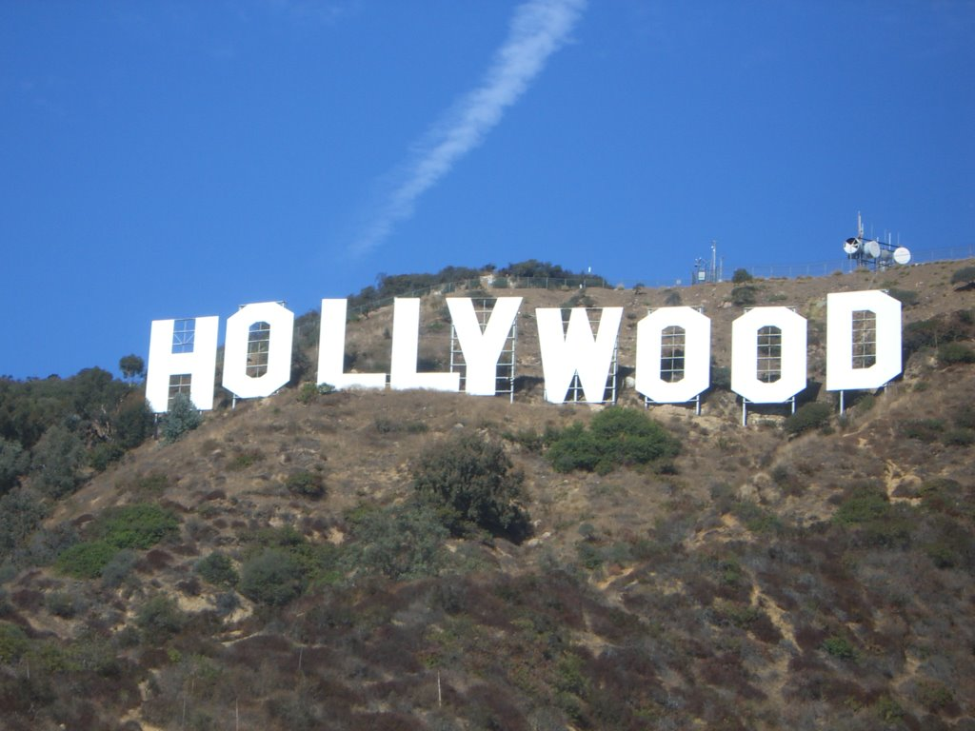](http://www.panoramio.com/photo_explorer#user=26487&with_photo_id=295848&order=date_desc)

**Film Music Composition Booklet**

**Name: _____________**

**Date: _____________**

*“You can go to school forever, but you’re never really going to learn until you just do it.”*

Michael Giacchino (Film Composer)

To complete the Composing Skills Unit, you must complete all of the tasks in this booklet and compose a piece of **film** **music** including at least **8 concepts at Higher and National 5 level**.

You must also complete the Composing Mini Tasks booklet.

|  |  |
| --- | --- |
| **Composing skills** | 1.1 *Analysing how a range of compositional methods and music concepts are used by other composers and the influences on their music* |
| 1.2 *Experimenting and using complex music concepts and compositional methods in creative ways to develop refine and create original music* |
| 1.3 *Developing musical ideas which make musical sense and realise their creative intentions* |
| 1.4 *Critically reflecting on their music and their creative choices and decisions* |
| **Understanding Music** | 1.1 Identifying and distinguishing between complex level-specific music concepts in excerpts of music |
| 1.2 Analysing the impact of social and cultural influences on the development of specific music styles |
| 1.3 Analysing and using a variety of music signs and symbols and terms |

*Use this booklet as a guide to help your creative process throughout this task.*

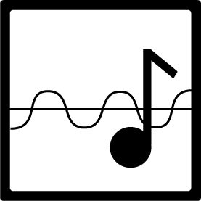

Tick off each task as you complete it. You must also show your progress to your teacher.

|  |  |  |  |
| --- | --- | --- | --- |
| Task 1 | * Jurassic Park listening * Dark Knight listening | Date completed: | CS 1.1  UM 1.1 |
| Task 2 | * Compositional approaches | Date completed: | CS 1.1 |
| Task 3 | * Analysing Somewhere in Time | Date completed: | UM 1.3 |
| Task 4 | * Schindler’s List task | Date completed: | UM 1.2 |
| Task 5 | * Chase scene mini task * Love scene mini task * Storm scene mini task | Date completed: | CS 1.2  UM 1.1 |
| Task 6 | * Film composition including reflection | Date completed: | CS 1.3 |

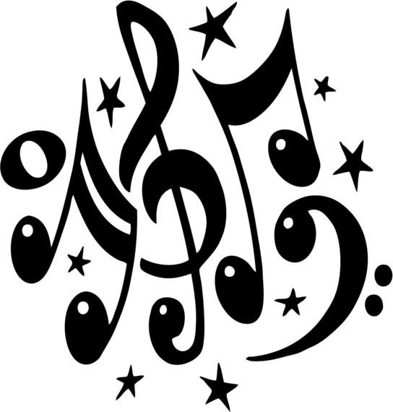**Task 1 - Analysing the film music of John Williams and Hans Zimmer**

1. Listen to the beginning of the theme tune to ‘Jurassic Park’. This music is composed by John Williams.

<http://www.youtube.com/watch?v=D8zlUUrFK-M>

As you listen, answer the questions below. If you wish to follow the score it can be found here (Computer > Subjects > Music > Higher Music > Jurassic Park)

**Consider the following questions;**

1. What instruments do you hear? How are they being played?

________________________________________

1. Is the piece major/minor/atonal?

________________________________________

1. How fast or slow is this piece? Do you hear syncopation/cross rhythms/time changes?

________________________________________

1. Is this song strophic/through composed/binary/ternary form?

________________________________________

1. How would you describe the dynamics? Are there changes in dynamics?

________________________________________

1. Now listen to ‘And I thought my jokes were bad’ from the ‘Dark Knight’. This music is composed by Hans Zimmer.

<http://www.youtube.com/watch?v=Z7EIDzJ5F3g>

As you listen, answer the questions below:

1. What concept describes the string music at the beginning? _________________
2. Notate the rhythm you hear for the first time at 27 secs.



1. Complete the grid below identifying the concepts you hear. Refer to the table on the previous page for points to consider

|  |  |  |  |
| --- | --- | --- | --- |
| Melody/Harmony | Rhythm/Tempo | Texture/Structure/  Form | Timbre/Dynamics |
|  |  |  |  |

Show your work to date to your teacher and tick off the task at the front of your composing booklet.

**Task 2 – Compositional Approaches – Pair and Share**

**John Williams** and **Hans Zimmer** have different approaches to writing music. You will now research each composer working in pairs. Each person should choose **one** composer and watch their videos. Present your findings to your partner to your partner and vice versa.

**John Williams**

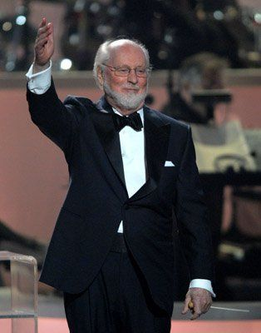**Interview** – <http://www.youtube.com/watch?v=zNX2rNaCDso>



**Indiana Jones** - <http://www.youtube.com/watch?v=THMZl5OfCHQ>



**ET** - <http://www.youtube.com/watch?v=Nx7NiJHIlGs>

**Hans Zimmer**

****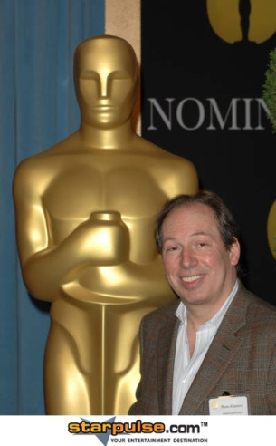**Making of Inception** - <http://www.hans-zimmer.com/index.php?rub=media>



**Sculptural Percussion** - <http://www.hans-zimmer.com/index.php?rub=media>

**The Joker Theme** - <http://www.youtube.com/watch?v=vt5_TB3mB2U>

Show your work to date to your teacher and tick off the task at the front of your composing booklet.

**Task 3 – Analysing ‘Somewhere in time”.**

Look at the score on the next page and answer the following questions.

<https://www.youtube.com/watch?v=esrTfwBiOM0>

1. Insert the time signature at the appropriate place.
2. Look at the first three notes. What word would describe the rhythm?

____________________________________

1. The key of the piece is C major. Insert the chords in the boxes at bars 5 and 6.
2. Identify the intervals at letters A and B.
3. Write the note names at the point marked *

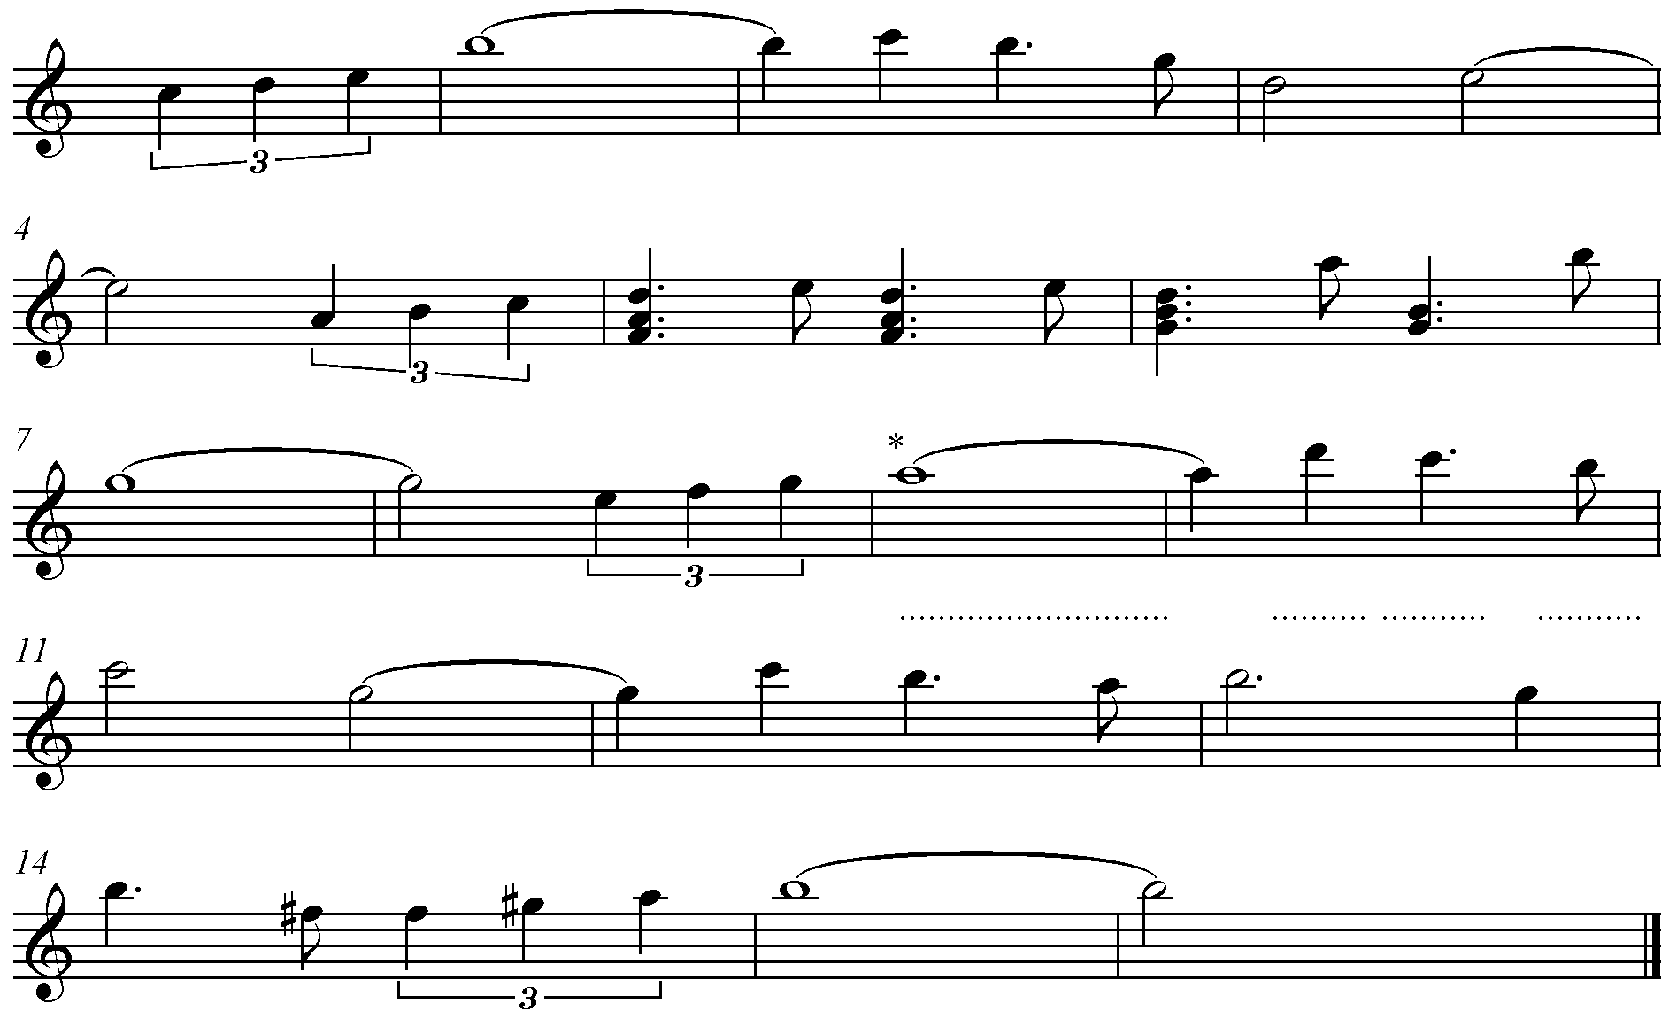

A

B

Show your work to date to your teacher and tick off the task at the front of your composing booklet.

**Task 4 – (UM 1.3) You are required to analyse the impact of social and cultural influences on the development of specific music styles.**

Schindler’s List (released in 1993) is a film based on the novel Schindler’s Ark by the Australian author Thomas Keneally. It is based on the life of Oscar Schindler, who saved the lives of more than a thousand Polish-Jewish refugees during the Holocaust.

1. Write a short paragraph describing The Holocaust. You can write this in sentences or you can use bullet points.

You may wish to use the following website:

<http://www.ushmm.org/wlc/en/article.php?ModuleId=10005143>

1. Next, find out a bit of information about Oscar Schindler. Who was he and what did he do?
2. You are now going to look at the music of the theme tune from Schindler’s List and identify some key features. Listen to the audio here:

<https://www.youtube.com/watch?v=ueWVV_GnRIA>

The Musescore file can be found in Subjects>Music>

1. What key is this piece in? Do you think this has any relevance to the subject of the film? _______________________________________________________________
2. How would you describe the tempo? Use Italian words _______________________
3. What technique(s) is the violinist using? Explain how this reflects the mood of the piece. __________________________________________________________

_______________________________________________________________

1. What form is this piece in (if any)? _____________________
2. 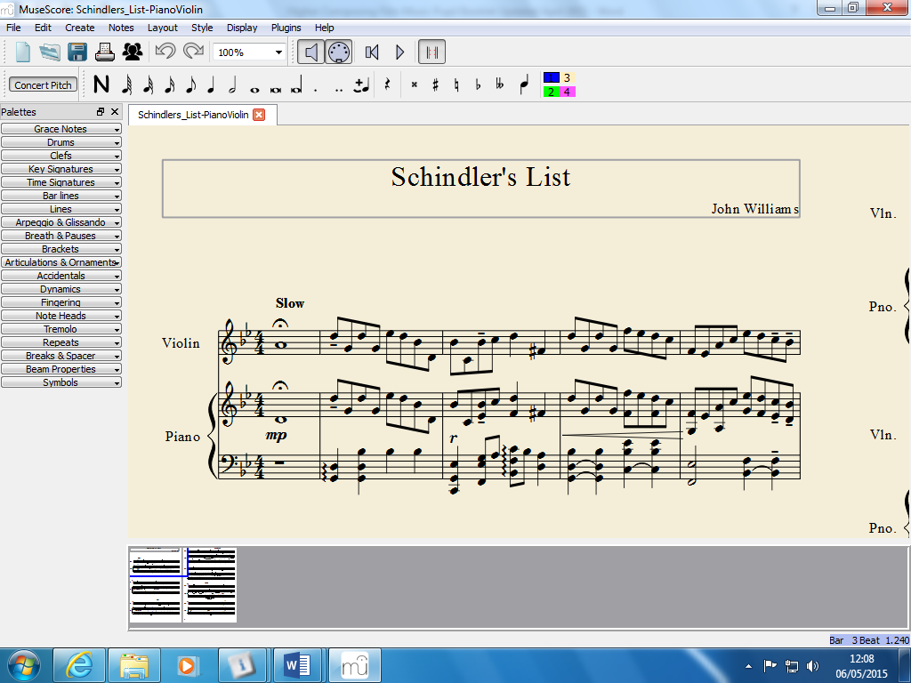What term is given to the sign above the first note in the violin part? __________
3. What accidentals are used in this piece?________________________________
4. Describe the interval formed by the notes in the upper piano part in bar 5. ________________________________________
5. What term would describe the rhythm in the middle section starting at bar 12?

____________________________________________________________________

1. Does this rhythm reflect the mood of the piece/film? Explain your answer.

_____________________________________________________________________

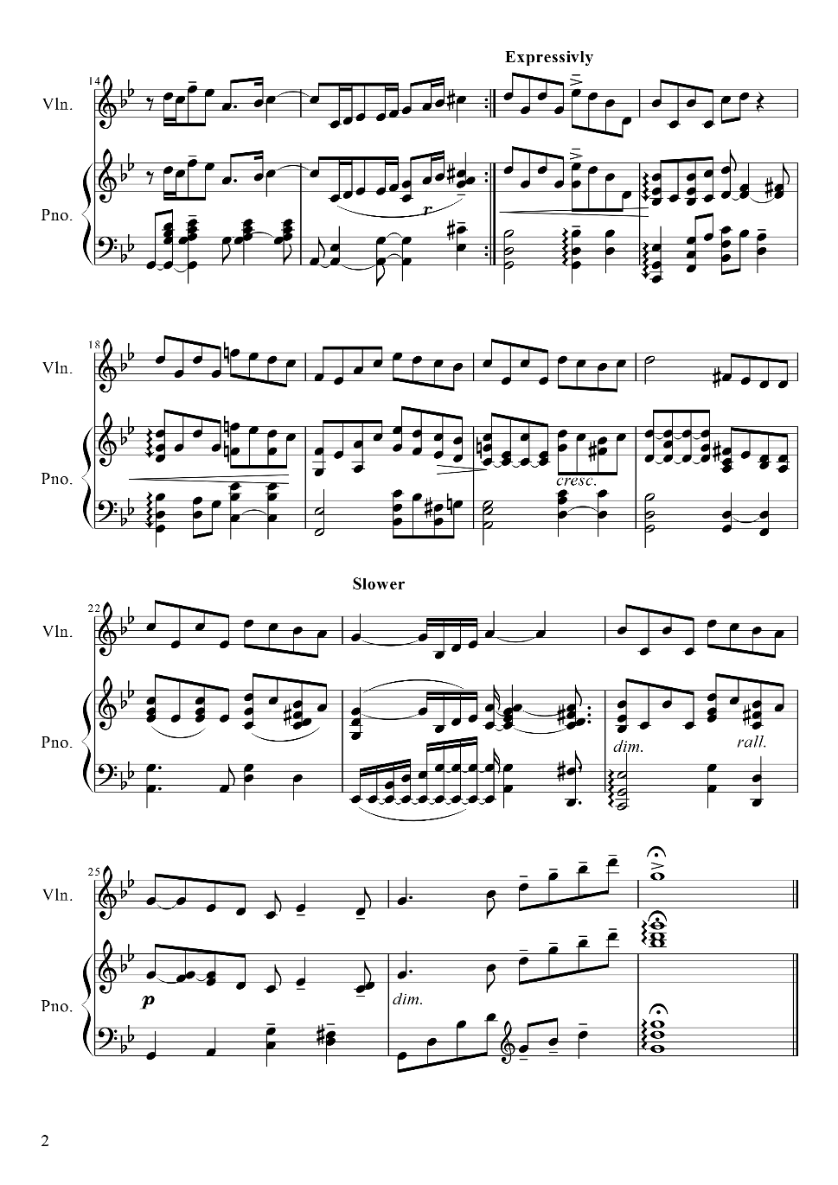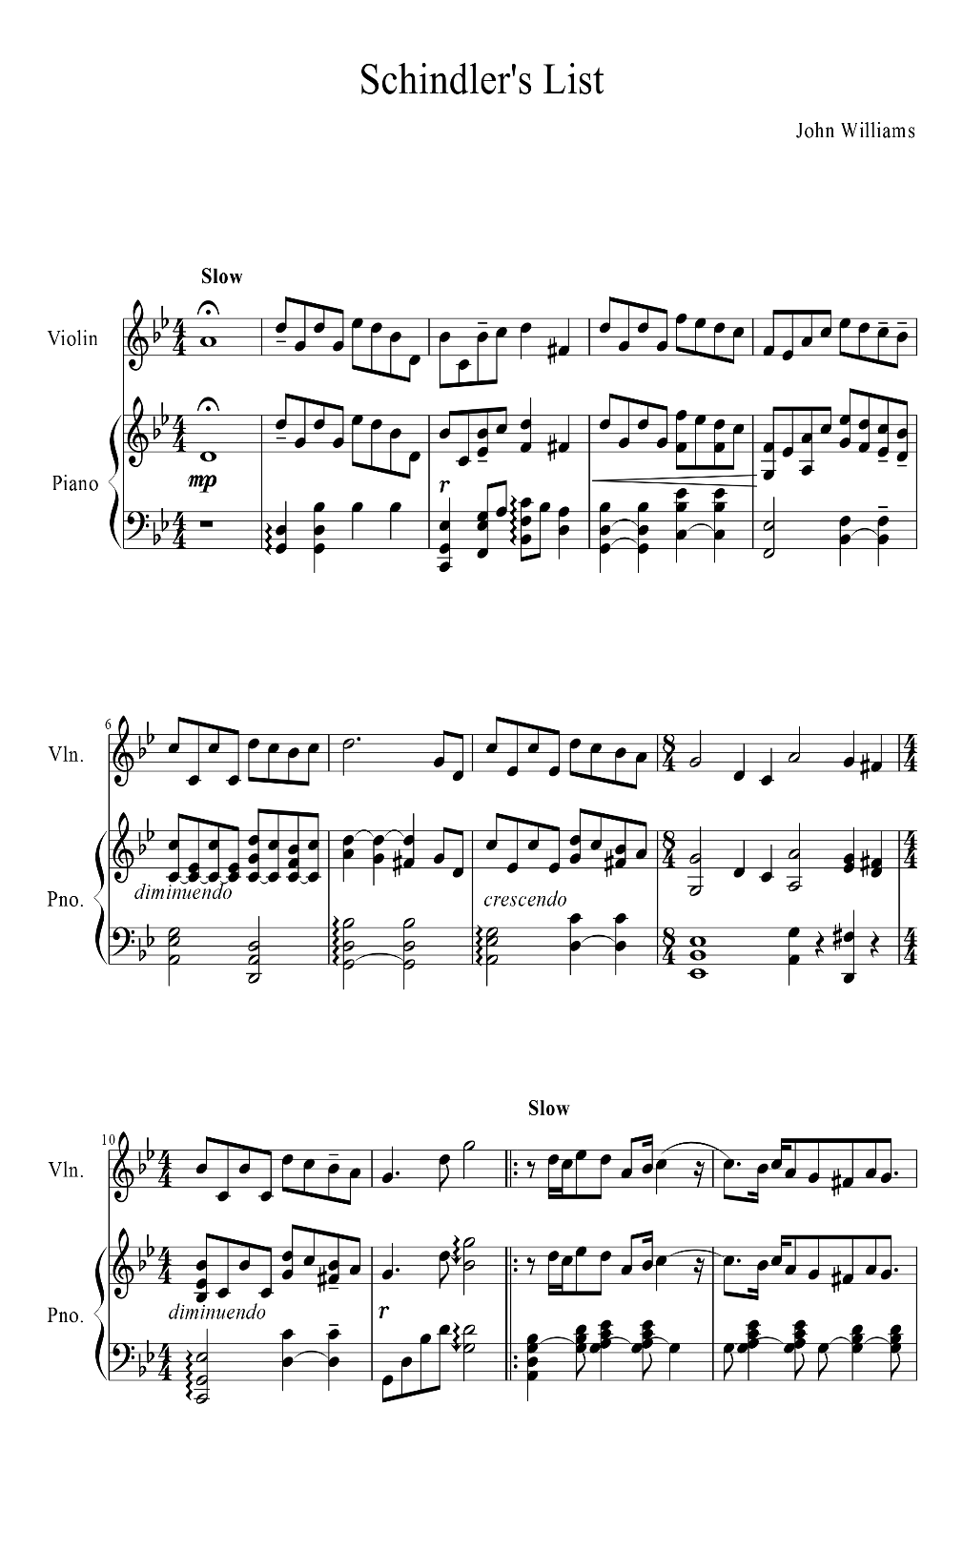

1. **C:\Users\sfindlater950\AppData\Local\Microsoft\Windows\Temporary Internet Files\Content.IE5\K2ALDO3J\MC900438185[1].wmf**Investigate any other composers of music relating to The Holocaust. Are these primarily film composers or are they composing music in other styles? Choose one of their pieces and identify the key music concepts you hear in each section of music, using the following headings as a guide:

Composer: __________________________

Piece: ______________________________

* melody/harmony
* rhythm/tempo
* texture/structure/form
* timbre/dynamics

You should place your concepts under the appropriate heading in the following table.

|  |  |  |  |
| --- | --- | --- | --- |
| Melody/Harmony | Rhythm/Tempo | Texture/Structure/Form | Timbre/Dynamics |
|  |  |  |  |

***Choose one of the pieces you have been listening to that are influenced by The Holocaust and create a mind map which demonstrates the impact of the social and cultural influences on the music. You should include concepts such as features used in music, instruments and how they are used, tonality, form/structure, tempo.***

Submit your mind map to your teacher and tick off the task at the front of your composing booklet.

**Task 4 – Experimenting and using music concepts and compositional methods in creative ways to develop refine and create original music**

You will now build up your film composing skills by writing at least 4 bars of music for **3** different scenes that are listed below. After you have completed these short pieces, you will then further develop your skills by composing an extended composition on one of these themes.

1. **Composing music for a chase scene**
2. **Composing music for a love scene**
3. **Composing music for a storm scene**
4. **Chase scene**

Watch the following scene from “Inception”, the music is provided by Hans Zimmer: <http://www.youtube.com/watch?v=s_6fKA334gk>

Is the music appropriate for the scene, and if so, how? Try to use concepts from your concept grid.

______________________________________________________________________________________________________________________________________________________

Are the instruments selected appropriate? What techniques are the instruments using?

______________________________________________________________________________________________________________________________________________________

What Higher/Nat 5 concepts do you think could be added to this to add an extra dimension to this score?

______________________________________________________________________________________________________________________________________________________

**Composing mini task 1**

1. Given that ostinato features heavily in this excerpt, **compose your own 4 bar ostinato** to accompany this score. This could be notated in a number of ways including, on manuscript, using Sibelius, Muse Score or Notion. You could record your ostinato using one of the apps on the iPads..
2. Once you have created your ostinato, **add an additional part**. This could be as simple or as complex as you like. This additional part should use a Nat5 or Higher concept.



|  |
| --- |
| **Reflection**  Did the additional part fit in harmonically with your ostinato? Is there anything you could have done differently?  __________________________________________________________  __________________________________________________________  **MC900440428[1]**Are there any skills/techniques that you’ve learned here that you could use in your final composition?  __________________________________________________________ |

Show your work to date to your teacher and tick off the task at the front of your composing booklet.

1. **Love Scene**

Listen to ‘Across the Stars’ which is the love theme from ‘Star Wars II Attack of the Clones’.

<http://www.youtube.com/watch?v=9nk_WHHTQtY>

What concept best describes the accompaniment? ____________________________________________

What instrument plays the melody at the beginning? _____________________________________________

What instrument(s) could be used to play your love theme?

_____________________________________________

**Composing mini task 2**

1. Compose your own 4 bar melody. Think carefully about which instrument will play this and try to use appropriate concepts for that instrument. At first you should keep your melody really simple – it can easily be made more difficult later.
2. Once this is done, compose a bass part that will accompany your melody. Again, think about what instrument you want to accompany and what type of accompaniment is appropriate e.g.- walking bass/drone/alberti bass/broken chords etc.

(Tip – you may find it easier to write your accompaniment/chords first)



|  |
| --- |
| **Reflection**  What instrument(s) did you use? Why did you choose this particular instrument(s)?  __________________________________________________________  __________________________________________________________  What techniques did you use? E.g. pizzicato, glissando, muted, etc.  __________________________________________________________  __________________________________________________________  Are there any skills/techniques that you’ve learned here that you could use in your final composition?  __________________________________________________________  Do you feel you were successful in achieving the sound you wanted?  If you were to do the task again, what would you do differently next time?  __________________________________________________________  __________________________________________________________ |

**MC900440428[1]**

Show your work to date to your teacher and tick off the task at the front of your composing booklet.

1. **Storm Scene**



Listen to ‘Superfreeze’ from ‘The day after Tomorrow’:

<http://www.youtube.com/watch?v=MFNK9lgc0iQ>

To create the feeling of bad weather approaching, the composer uses a wide variety of concepts. The concepts the composer has chosen here are commonly used when creating ‘storm’ music. Note how the music deliberately sounds fragmented – there is no melody as such. As you are listening to this excerpt, consider the questions below.

**Consider the following questions;**

1. What instruments do you hear? How are they being played?

________________________________________

1. Is the piece major/minor/atonal? – circle the correct answer
2. How fast or slow is this piece? Do you hear syncopation/cross rhythms/time changes?

________________________________________

1. Is this song strophic/through composed/binary/ternary form?

________________________________________

1. How would you describe the dynamics? Are there changes in dynamics?

________________________________________

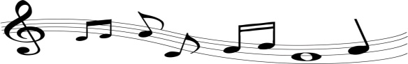

**Composing mini task 3**

* Experiment with some of the concepts you have identified above to create 4 bars of ‘storm’ music.
* Think carefully about Timbre.
* Also consider using dynamics (pp, mp, mf, f, ff, sfz, >)
* You may wish to use Garage Band on the iPad for this task.

|  |
| --- |
| **Reflection**  What concepts did you use? Explain how you used these.  __________________________________________________________  __________________________________________________________  Are there any skills/techniques that you’ve learned here that you could use in your final composition?  __________________________________________________________  Do you feel you were successful in achieving the sound you wanted?  If you were to do the task again, what would you do differently next time?  __________________________________________________________  __________________________________________________________ |

**MC900440428[1]**

Show your work to date to your teacher and tick off the task at the front of your composing booklet.

**Outcome 1.3**

**Developing musical ideas which make musical sense and realise their creative intentions**

**Film Composition**

Have a look at the 3 videos below. Your task is to write a piece of music for **one** of these clips. You will draw together all of the skills you have learned from the previous 3 mini composing tasks. Your need to decide if you are using the video as a stimulus for an independent composition, or if you want the music to convey what is happening in the film. This decision will determine whether the music needs to be synchronised with the clip. Your music must include at least 8 concepts and be at least 16 bars long.

1. Chase scene from ‘The Fast and the Furious’ –

 <http://movieclips.com/rtp4-2-fast-2-furious-movie-bridge-jump/>

1. Love scene from ‘My Best Friend’s Wedding’ –

<http://movieclips.com/z5hd-my-best-friends-wedding-movie-choose-me/>



1. Storm scene from ‘Perfect Storm’ –

<http://movieclips.com/nYHu-the-perfect-storm-movie-the-giant-wave/>



|  |  |
| --- | --- |
| **Title of composition:** | |
| **Concepts:** | |
| 1. Explain the style of your music – why have you chosen this particular style? |  |
| 1. What structure (if any) is your composition in? i.e. binary, ternary, rondo, ritornello, verse and chorus, strophic etc. |  |
| 1. What instruments have you included in your piece – have you used any techniques specific to these instruments? |  |
| 1. Explain the changes that you have made throughout the process, i.e. how have you experimented with your ideas? |  |
| 1. What would you improve and why? |  |
| 1. Are you happy with your overall composition? Explain why. |  |
| Date: | Pupil Signature |
| Date: | Teacher Signature |