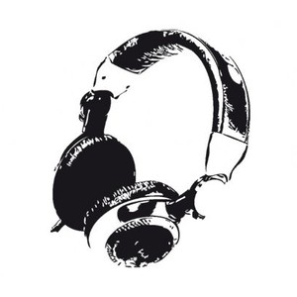
EFFECTS MATCH
Match up the correct effects to their appropriate definitions using the table below.

HIGH EQ BOOST | REVERB | WAH WAH | DISTORTION
PHASING/FLANGING | LOW EQ BOOST | CHORUS | COMPRESSION
DELAY | GATED REVERB | GATING

- _______________________________________
An audio processing technique that is applied to recordings of drums (or live sound reinforcement of drums in a PA system) to make the drums sound powerful and "punchy," while keeping the overall mix clean and transparent-sounding.

- ____________________________________________
Used to thicken sound and gives the effect of more than one instrument playing at the same time.

- ______________________________________________
The alteration of an audio signal due to poor quality electronic components, faulty leads or excessively high amplifier levels. It is used deliberately as an electric guitar effect to create a raw sound.

- _____________________________________________
An effect that combines an audio signal with a short delay to create phase differences. This produces a sweeping effect like an aeroplane passing by.

- ______________________________________________
An effect produced by repeating a sound slightly behind the original.

- _______________________________________________
An effect that reduces the dynamic range of audio signals by increasing the level of low signals and reducing the level of high signals. It creates a more balanced mix.

- ________________________________________________
An effect that constantly change the volume (amplitude) of harmonics in a sound. This alters the sound of the signal making it sound similar to a human voice saying “wah”.

- _________________________________________________
A device used in recording to reduce background noise. It only allows sound through when it is above a specified volume threshold.

- _____________________________________________
Imitates natural reflections of sound created in enclosed spaces e.g. halls or stadiums. This creates a sense of space and distance.

- ________________________________________________
The lower frequencies of a pitch are boosted, reducing the treble frequencies. The bass tones are more audible.

- _________________________________________________
The higher frequencies of a pitch are boosted, reducing the lower frequencies. The treble tones are more audible.

