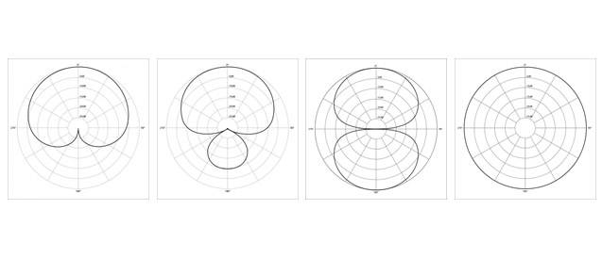

Microphone Polar Patterns
The polar pattern of a microphone is the sensitivity to sound relative to the direction or angle from which the sound is captured / recorded from. There are four main types of polar pattern:

Cardioid = Picks up most of the sound from the front axis of the microphone
A cardioid microphone is most sensitive on the front axis It reduces unwanted ambient sound from the sides and back and is much more resistant to feedback than other polar patterns.
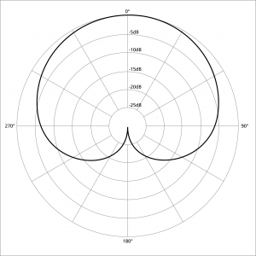
Microphone Polar_pattern_cardioid

Hyper Cardioid =Is a more frontwards directional pattern with minor rear spill
Hyper cardioid microphones offer a narrower pickup on the front axis than cardioids and a greater rejection of ambient sound from the sides. Hyper cardioids are most suitable for single sound sources that need to be picked up in loud environments.
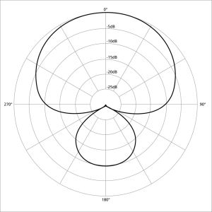
Microphone-Polar-Pattern Hyper-cardioid

Figure of 8 = Picks up sound equally from both the front and the back of the microphone
A microphone with a figure of eight polar pattern picks up the sound evenly from the front and rear of the microphone but not the side. Microphones with a Figure of Eight polar pattern are typically Large Diaphragm Microphones.
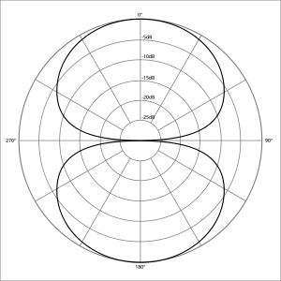
Microphone-Polar_pattern_figure_eight

Omni Directional = Picks up sound equally from every direction of the microphone
An omnidirectional microphone picks up sounds from all directions evenly and can be useful when picking up the entire room ambience / performance.
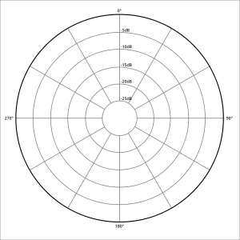
Microphone-Polar_pattern_omni Directional

