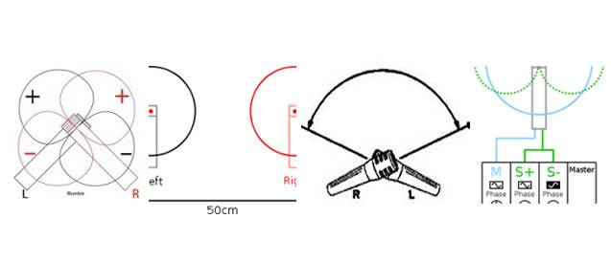

Microphone – Stereo mic techniques
There are various ways of recording a sound using two or more microphones, these are all referred to as stereo microphone techniques. The names are as follows:
- Spaced Pair (Left, Right pair)
- Coincident pair (X Y pair)
- Blumlein technique
- Mid Side technique
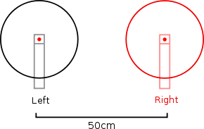  Microphone Technique AB Stereo Pair or spaced pair | 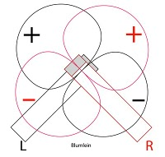  Microphone Technique Blumlein Stereo pair
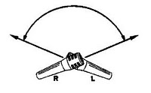  Microphone Technique coincident pair or X Y pair | 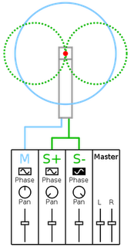  Microphone Technique Mid-side stereo pair

Stereo microphone techniques explained:
For more information on various recording techniques, this booklet produced by Shure gives an in depth look at the techniques and practices used by professional studio engineers:

