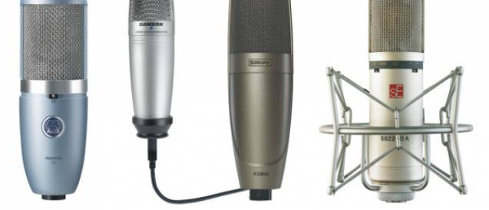

Microphone – Types
When selecting microphones to use for a live performance or in your home studio, you’ll come across four different types: Ribbon, Boundary, Dynamic and Condenser / Capacitor. Let’s look at these microphone types, and what their advantages and disadvantages are.

Dynamic:
Dynamic microphones are versatile and ideal for general-purpose use. They use a simple design with few moving parts. They are relatively sturdy and resilient to rough handling meaning they are better for live sound. They are also suited to handling high volume equipment such as amplifiers and other instruments. They have no internal amplifier and do not require batteries or external power.
- Doesn’t need 48v of Phantom power
- Only captures sounds that are very close to the axis of the microphone
- Good for noise reduction and getting the cleanest signal at a live venue
- Shure sm58, Shure sm57, AKG D112
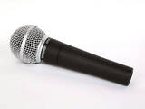 | 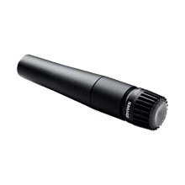 | 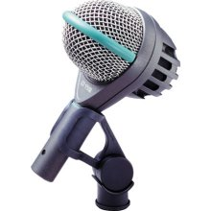
shure_SM58 dynamic microphone | Shure SM57 Dynamic microphone | AKG D112 dynamic microphone
How a Dynamic microphone works:
A magnet is moved near a coil of wire and an electrical current is generated in the wire. Using this electromagnet principle, the dynamic microphone uses a wire coil and magnet to create the audio signal. The diaphragm is attached to the coil. When the diaphragm vibrates in response to incoming sound waves, the coil moves backwards and forwards past the magnet. This creates a current in the coil, which is channeled from the microphone along wires.

Condenser / Capacitor:
A condenser microphone is fragile and more sensitive to sound. The pick up higher pitched and more detailed sounds but cannot withstand high sounds. They are good at picking up really quiet sounds. Condenser microphones require power from a battery or external source. These microphones are best used to record a voice or an acoustic guitar.
- Needs 48v of Phantom power
- Suitable for studio recording as they are very sensitive
- The large diaphragms are very fragile
- Rode NT2, Rode NT5, AKG C1000′s
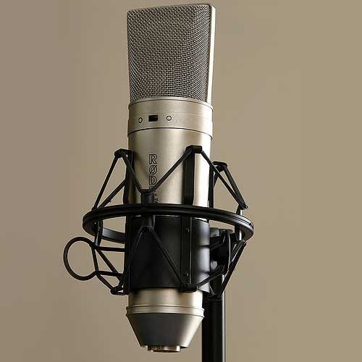  Rode NT2 condenser microphone | 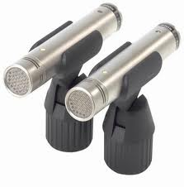  Rode NT5′s condenser microphone | 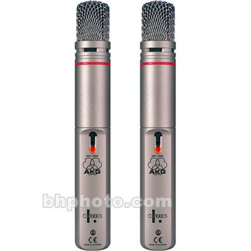  AKG 1000s condenser microphone
How a condenser microphone works:
A capacitor has two plates with a voltage between them. One of these plates is made of very light material and acts as the diaphragm. The diaphragm vibrates when struck by sound waves, changing the distance between the two plates and changing the capacitance. When the plates are closer together, capacitance increases and a charge current occurs. When the plates are further apart, capacitance decreases and a discharge current occurs. A voltage is required for a condenser microphone to work. This voltage is supplied by a battery or by phantom power (48volts).

Ribbon Microphone:
A ribbon microphone is a unique type of dynamic microphone that is based around a thin, corrugated strip of metal (often aluminium) or film suspended between two magnetic poles. Unlike traditional moving-coil dynamic mics, the ribbon element responds to variations in the velocity of air particles, rather than the pressure. As the ribbon vibrates within its magnetic field, it generates a tiny voltage that corresponds to these changes in velocity. In classic ribbon designs, this level is very low compared to typical dynamic mics, and a step-up transformer boosts both the output voltage and impedance. Preamp choice is very important when using ribbon mics.
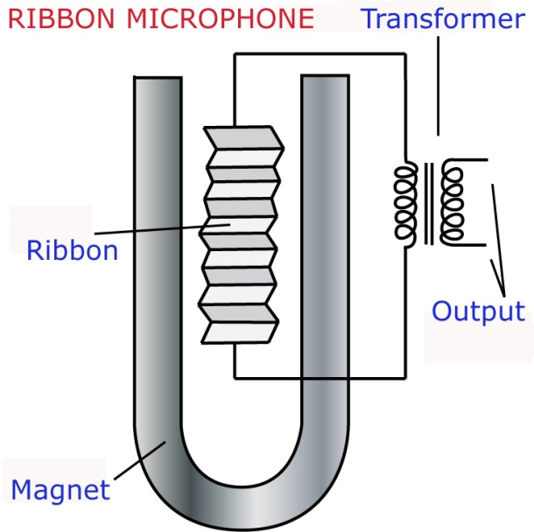
Because a ribbon mic has an extremely thin, delicate element, it is capable of capturing fast transients. Ribbons mics have a wide dynamic range, and are capable of handling high SPLs at high frequencies. (Give them a try on brass or percussion.) These mics are bidirectional by design, because the ribbon element responds to sound arriving from the front or back of the mic, and does not pick up sound arriving on its sides. This natural figure-8 pattern makes them ideal for stereo recording applications, and is useful in applications where you want to eliminate unwanted noise between two sources (i.e. in broadcast).
Ribbon mics are very sensitive, but they are often quite fragile; delicate older models can be broken by strong gusts of air, voltage spikes or even by being stored on their side. – See full ribbon microphone article and more at: http://www.emusician.com/horns/0786/ribbon-mics-explained/136136#sthash.s69FbsRj.dpuf

Boundary Microphone:

